**Vegetarian or Lenten Specials**

**Sandwich Specials**

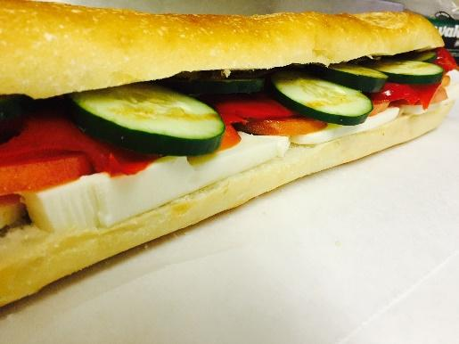

**Veggie Delight**

Hummus, Guacamole, Spinach, Cucumber, Lettuce and Tomato

$8.95

**Grilled Vegetable**

Zucchini, Squash, Mozzarella, Roasted Red Peppers, and Pesto on a Grilled Whole Wheat Panini

$8.95

**Gal Friday**

Fresh Mozzarella, Tomato, Fresh Basil, Roasted Red Peppers, and Balsamic Vinegar

$8.95

**Eggplant Parmesan**

Breaded Eggplant, Marinara Sauce, and Mozzarella Cheese on Kaiser

$7.95

**Cat on a Hot Tin Roof**

Tuna, Horseradish Cheese, Tomatoes, and Onions

$7.95

**Chopper One**

Sliced Egg, American Cheese, Bacon (hold the bacon), Lettuce, Tomatoes, Onion, and Mayo

$8.95

**Darla June**

Tuna Salad, Melted Swiss, Lettuce, Tomatoes, Onion, and Mayo

$7.95

**Gary Cummings**

Egg Salad, Bacon (hold the bacon), Melted Muenster, Tomatoes, Onion, and Shedd’s Sauce

$8.95

**Jaws**

Tuna Salad, Havarti with Dill, Tomatoes, Onion, and Russian

$7.95

**Spencer’s Special**

Egg Salad, Bacon (hold the bacon), Onions, and Mayo

$7.95

**Grilled Cheese**

Choice of American, Swiss, Provolone, Muenster, or Cheddar

$5.95

ALL SANDWICHES MADE ON YOUR CHOICE OF WHITE, WHOLE WHEAT, RYE, OR KAISER ROLLS. PREMIUM BREADS INCLUDED WHOLE WHEAT WRAPS, 8-GRAIN, OR SUBS.

**Homemade Salad Specials**

**Caesar Salad** - $7.00

**Cole Slaw** - $3.99 per pound

**Garden Salad** - $5.00

**Macaroni Salad** - $3.99 per pound

**Pasta Salad**- $3.99 per pound

**Potato Salad**- $3.99 per pound

**Spinach Salad** - $7.00

